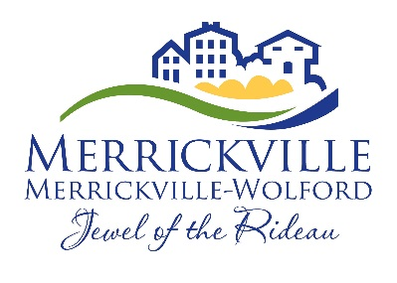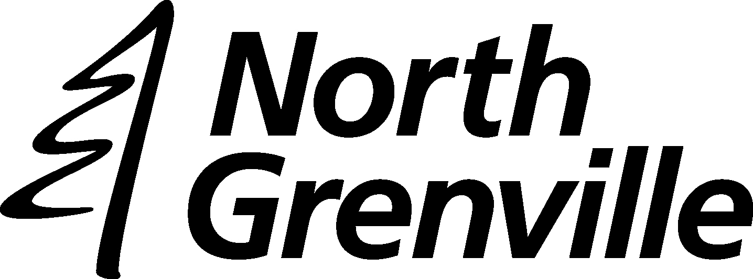

PROPERTY UTILITIES
Pre-Authorized Payment
Authorization Form

Please fill in and return this form to our office with one of your personal cheques unsigned and marked VOID (for verification purposes).

I/WE
Name(s) _____________________________________________________________________

Address _____________________________________________________________________

City _________________________ Province _________________ Postal Code ___________

Utility Account Number ____________________________ Phone #_________________

AUTHORIZE
Village of Merrickville-Wolford
PO Box 340
Merrickville ON K0G 1N0

TO DEBIT MY/OUR ACCOUNT
Bank Number |  |  |  |  | Transit Number |  |  |  |  |  | Chequing Account Number
0

Held at ______________________________________________________________________
Name of Financial Institution
____________________________________________________________________________
Branch Address
- For the purpose of payment of utility account in the amount of $_______________ per month on the first business day of the month, commencing the month of ________________.

- For the purpose of payment of utilities in the installment amount due as indicated on the utility bill, (generally due the last business day of January, March, May, July, September, and November) commencing ____________________________.

I/We have read and understood the terms of this authorization.

_________________________________ ______________________
Signature Date

_________________________________ ______________________
Signature* Date
* For joint accounts, all depositors must sign if more than one signature is required on cheques issued against the account.

TERMS AND CONDITIONS

Property owners are eligible if their account is paid up to their chosen date of enrolment.

I/We will notify the Village of Merrickville-Wolford in writing of any changes in the account information or termination of this authorization at least twenty (20) days prior to the next payment date.

I/We understand that termination of this authorization does not affect my/our obligation to pay for goods or service contracted for/with the Village of Merrickville-Wolford.

My/Our financial institution will treat each debit as if I/we had personally issued a written direction authorizing the Village of Merrickville-Wolford to debit the amount(s) specified to my/our account and need not verify that payments are drawn in accordance with this authorization.

I/We understand that any debits charged to my/our account will be reimbursed if:
- the debit was not drawn in accordance with this authorization;
- this authorization has been terminated; or
- the debit was posted to the wrong account due to invalid/incorrect account information supplied by the Village of Merrickville-Wolford,
by giving notice in writing to my/our branch of account within ninety (90) days of the debit to my/our account.

I/We acknowledge that delivery of this authorization to the Village of Merrickville-Wolford constitutes delivery to my financial institution.

I/We warrant that all persons whose signatures are required to sign up on this account have signed this authorization.

